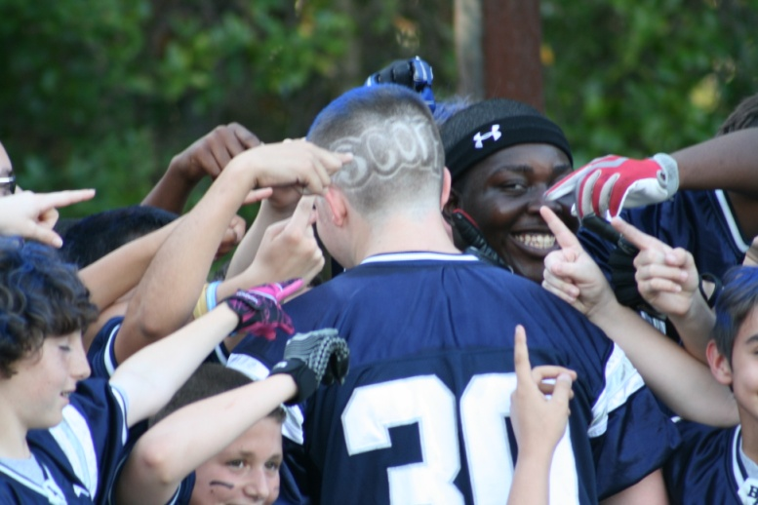
ALL THE WAY IN!!

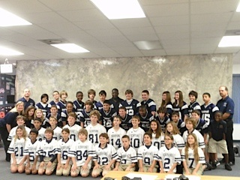
TEAM PHOTO 2012
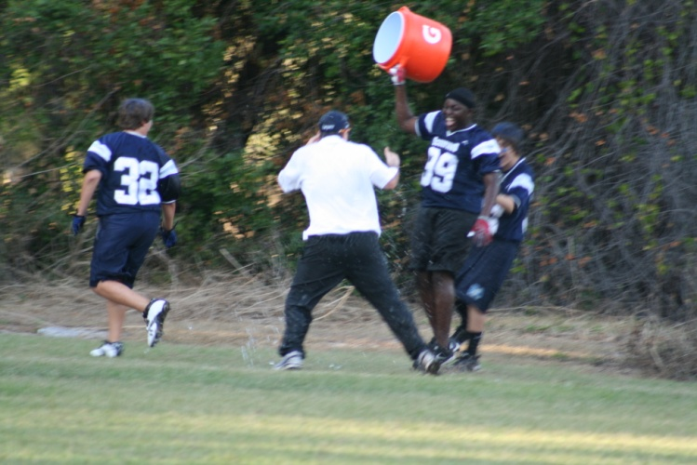
ANOTHER VICTORY, ANOTHER COLD SHOWER!
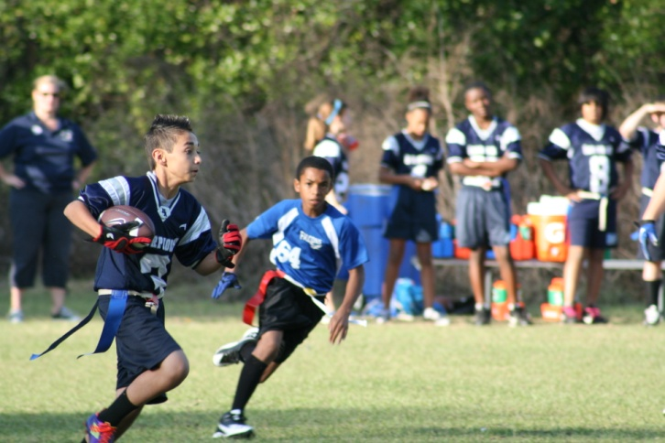
ZACK KAZ!!
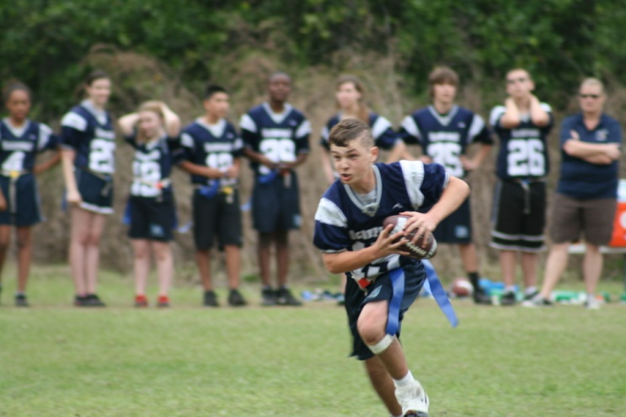
DYLAN RUDOLPH – WAR EAGLE
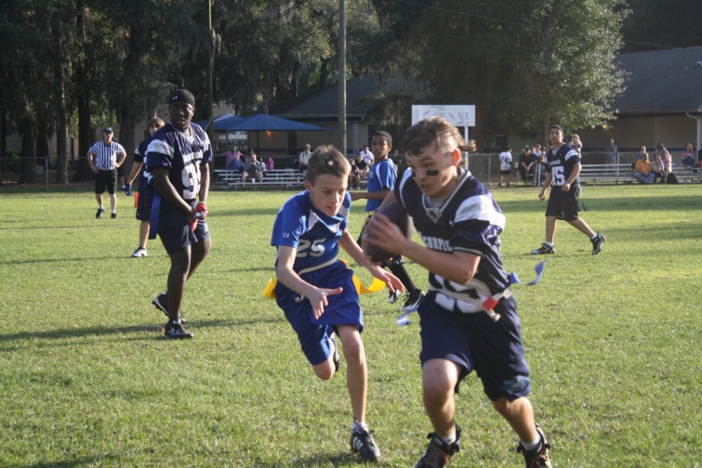
ONE OF A RECORD 17 TDS FOR THE SEASON
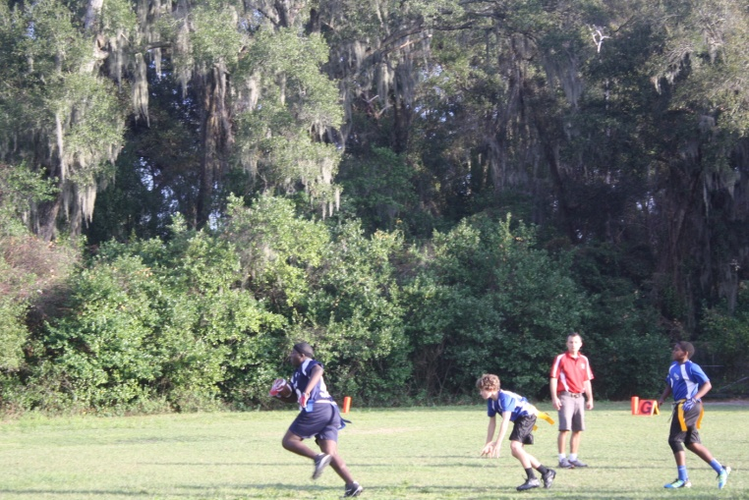
NOBODY STOPS RAY CAPEHEART
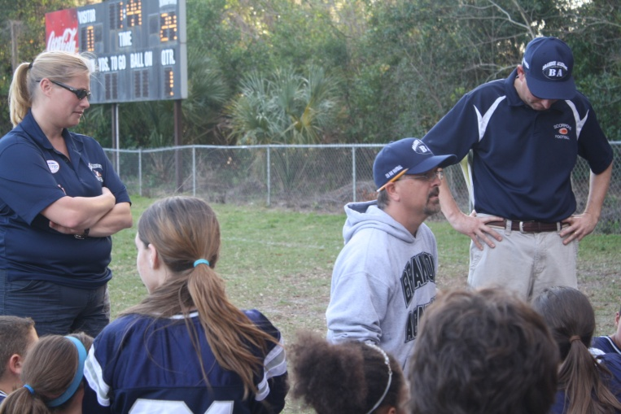
BIG LEAD AT THE HALF
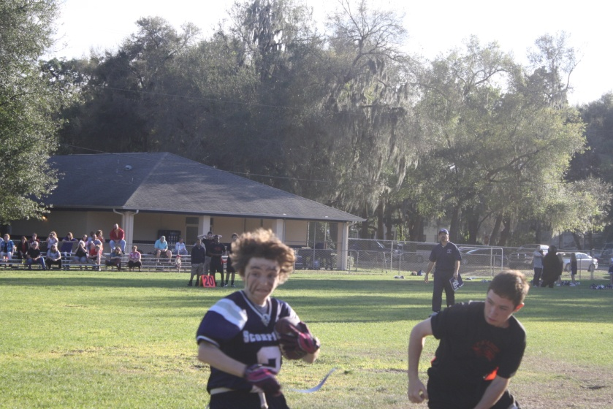
GAGE SEARS – COMIN’ AT YA
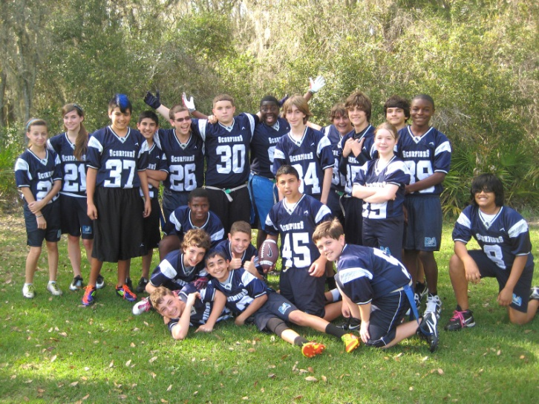
LOVING LIFE!
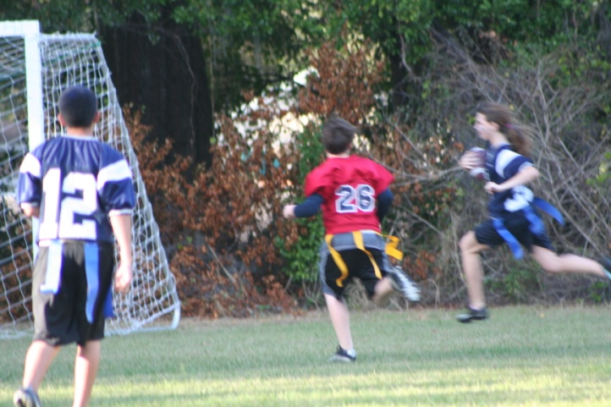
GIMBEL TO THE ENDZONE
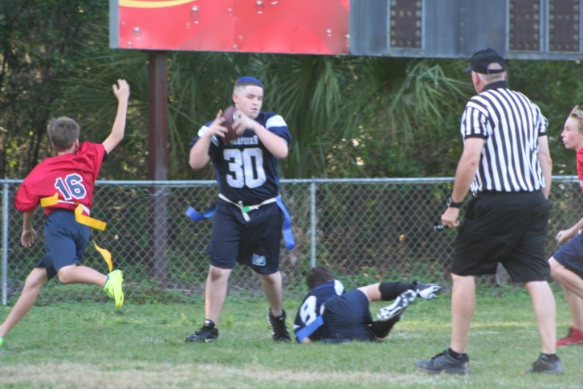
SHAWN ICENOGLE – HIS PLAYOFF INT WON’T BE SOON FORGOTTEN
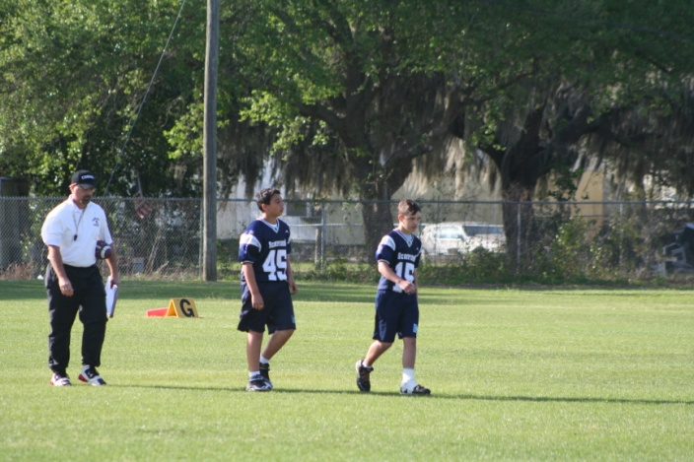
CHAMPIONSHIP GAME. THE THREE OF US HAVE BEEN TOGETHER FOR 7 YEARS.
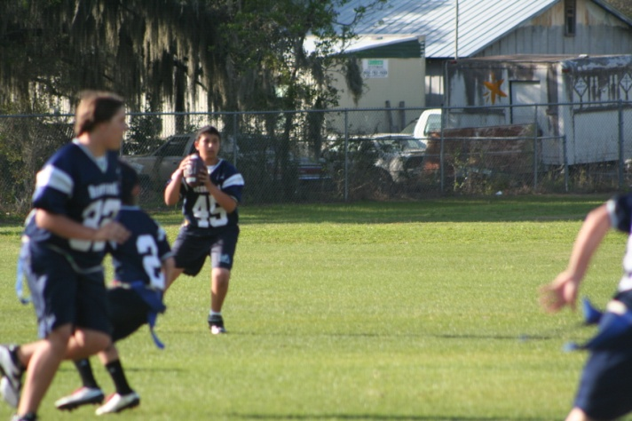
ADAM GHABOUR – MAKING IT LOOK EASY
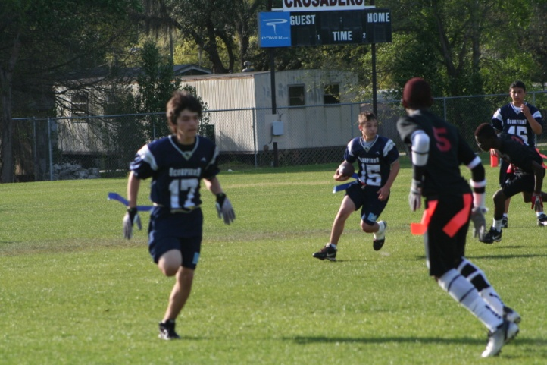
YOUSUF LATIF – A TREMENDOUS FIRST YEAR PLAYER
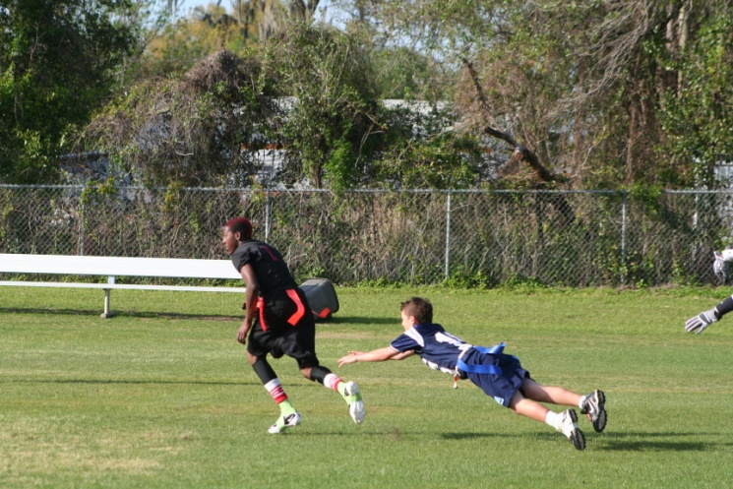
ZERO GRAVITY
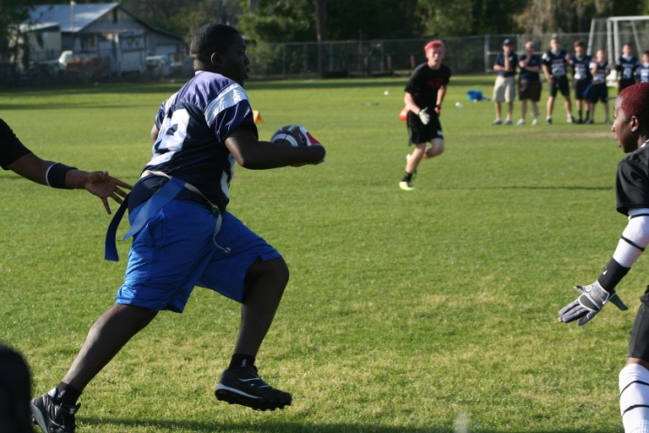
BIG PLAY RAY
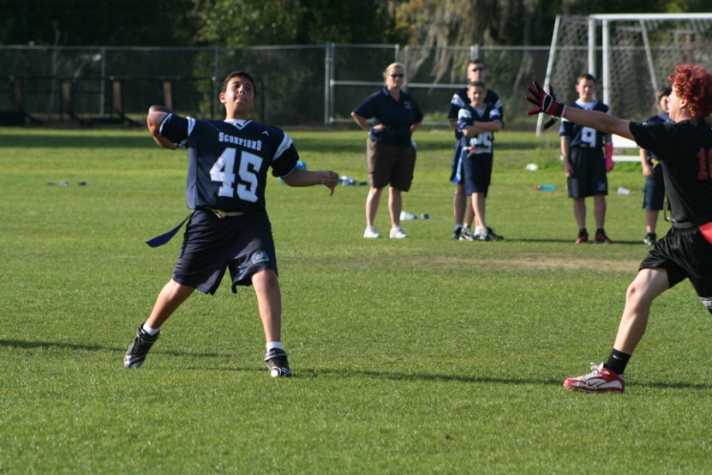
ADAM GHABOUR WILL ALWAYS BE REMEMBERED AS ONE OF THE GREAT BA QBs EVER
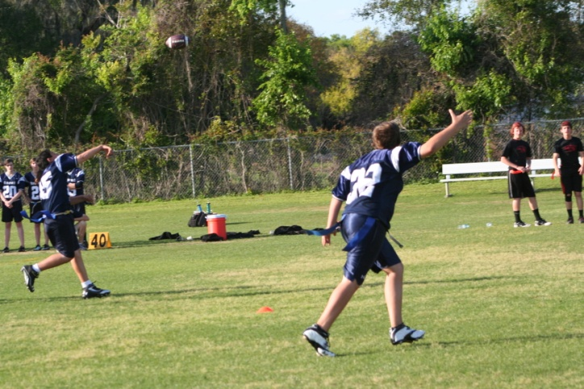
KYLE CRESICINI CALLING DOWN THE BALL
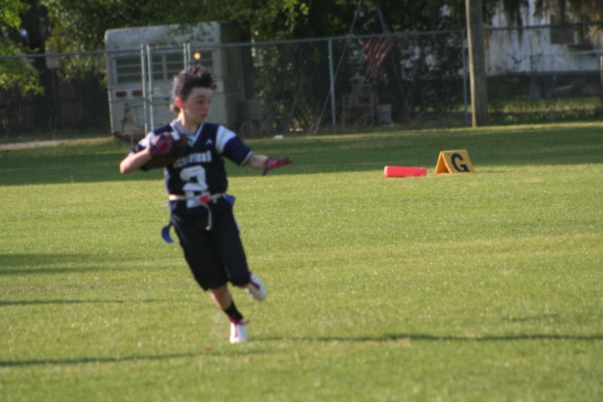
HEISMAN?
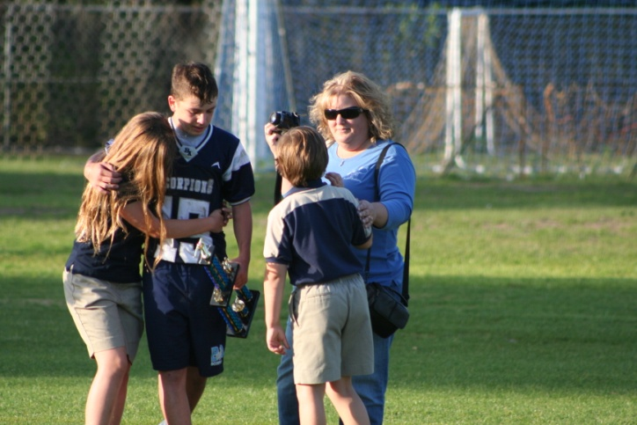
THE END OF AN ERA

